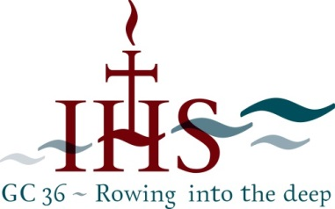
The Jesuit Curia in Rome
Borgo S. Spirito, 4, 00193 Roma (Italia)

Some Facts & Figures of GC36

Average Age: 56
Median Age: 55

DESIGNATION | NAME | PROVINCE | BORN
Oldest Member | Fr. Adolfo Nicolás | Japan | 29-04-1936
Oldest Elector | Fr. Bienvenido Nebres | Philippines | 15-03-1940
Youngest Elector | Br. James Edema | Eastern Africa | 07-11-1976
Youngest Priest Elector | Fr. Dany Younès | Near East | 15-05-1974

Participation by Conference

Conference | Number of Electors
Asia Pacific | 23
Europe | 58
South Asia | 46
Canada-USA | 33
Africa | 21
Latin America | 34
Grand Total | 215

Participation by Assistancy

Assistancy | ACRONYM | Number of Electors
Africa | AFR | 21
Latin America South | ALM | 17
Latin America North | ALS | 17
South Asia | ASM | 46
Asia Pacific | ASP | 23
Central & Eastern Europe | ECO | 21
South Europe | EMR | 18
West Europe | EOC | 19
USA | USA | 33
Grand Total |  | 215

Capacity of Participation

Participation in GC36 | Number of Electors
Brother Elector | 6
Conference President | 6
Council member | 13
Elector | 117
Fr General | 1
Major Official | 3
Member (FCG7) | 3
Provincial | 66
Grand Total | 215

NB:
Major Officials:
- Secretary of the Society
- Treasurer General of the Society
- Procurator General of the Society

Member (FCG7): The formula of the General Congregation allows Father General to summon other members “for the sake of greater information.” Father General has called:
- Fr. Thomas Smolich (International Director of JRS)
- Fr. Michael Garanzini (Secretary for Higher Education)
- Fr. José Mesa (Secretary for Secondary Education)

